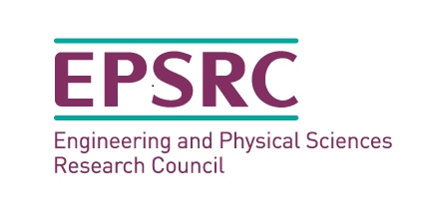
On-line Mentoring Course – sections and resources
*This course is best done over a period of time, in conjunction with being in a mentoring relationship, so you can assess your progress as a mentor or mentee in practice.

Aim - To introduce participants to the role of the mentor and mentee, within the context of the EPSRC project, and help them prepare for the mentoring relationship.

Section | Resources
1 Intro to EPSRC | Video  Script  Aims and Objectives of the course  Sections and resources sheet  Mentoring Handbook / Guide  Taxonomy  Reading list / links  - Shared Characteristics Research  - Women in Engineering Statistics  - Women in leadership (sponsorship through mentoring)
2 Mentoring – What is it? | Video  Script  - What is it? - Video, covering;  - what it is, push-pull spectrum (directed to non-directed)  - what it is not, solving people’s problems for them  - types (connects to career development and shared characteristics personal development),  - who can be a mentor (in this context), shared characteristics  - and what the role entails (role modelling)  - who can be a mentee (in this context), shared characteristics  - and what the role entails (responsibility, proactive, ownership)
3 Mentoring Skills | Video (1)  Video (2)  Script  - What are the skills, knowledge, experience and attributes needed? - Videos  - Skills self-assessment worksheet  Mentoring Skills self-assessment  Communications self-assessment  Reading list / links
4 Mentee Attributes | Video (1)  Video (2)  Video (3)  Video (4)  Script  - What are the skills, knowledge, experience and attributes needed? - Videos  - Attributes self-assessment worksheet  Mentee Attributes self-assessment  DISC Activity  Communications self-assessment  Urgent / Important Matrix  Reading list / links  - Behavioural models and their influence in the workplace  - Profiling and social networking  - Profiling and behavioural assessments
5 Building Rapport | Video (1)  Video (2)  Script  - Building the relationship - what does it take?  - Communication, rapport, support and challenge (knowing your mentor/mentee) - Videos  Rapport self-assessment  Curiosity self-assessment  Refining your EQ  Mindset and DISC  Reading list / links  - Neuroscientific Interplay between Growth Mindset and Intrinsic Motivation  - Cultural competence
6 Tools and Summing Up | Video (1)  Video (2)  Building Success  - Building success through the right tools - Videos  - GROW model, key questions, including confidence building, developing self-awareness, beliefs and barriers, being stuck.  Mentoring Handbook / Guide  Mentor self-assessment revisited  Mentee self-assessment revisited
7 Scenarios / Case Studies | To be added as we progress through the mentoring project.  - What are the key themes?  - What went well?  - What could have been done differently?

