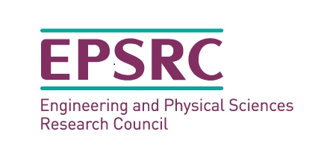

Communication self-assessment

Please circle where you think you are.

- How well do you know your own personality ‘default’ traits?

Extremely well.  I have undertaken a personality assessment and put my learning into practice. | Well.  I have undertaken a short personality activity, but have yet to put my learning into practice. | Not too sure.  I have not done the personality activity, but have done some reading around the area. | Not at all.  This is new to me.

- How well do you know your ‘default’ communication style?

Extremely well.  I have undertaken lots of communication training that has focused on my style/ approach and put my learning into practice. | Well.  I have undertaken some communication training that has focused on my style/ approach, but have yet to put my learning into practice. | Not too sure.  I have not done any specific training but have done some reading around the area. | Not at all.  This is new to me.

- How well do you know the ‘default’ communication styles of the people you communicate with the most frequently?

Extremely well.  I have done lots of communication training that has looked closely at the styles/ approaches of others and put my learning into practice. | Well.  I have done some communication training that has looked closely at the styles/ approaches of others, but have yet to put my learning into practice. | Not too sure.  I have not done any specific training but have done some reading around the area. | Not at all.  This is new to me.

For questions 4 – 7 use the table below to assess against.

Extremely good.  I have undertaken 360-degree feedback from those I communicate with mostly to confirm this judgement. | Good.  I have not sought any active feedback, but have received some positive comments. | Not too sure.  I have not sought feedback, but have never received adverse comments or complaints either. | Poor.  I have had some adverse comments or complaints.

- How good do you think your listening skills are?

- How clear are you when you address others?

- There are many aspects related to body language, such as, eye contact, stance, gesture, tone, pace. Overall, how good is your non-verbal communication?

- How clear is your written communications?

Overall then where do you think you are?

Add any thoughts or considerations you might want to pick up on later:

